**Software Requirements Specification**

**for**

**IMAGE CAPTION GENERATOR**

**Version 1.0 approved**

**Prepared by**

**Drishti Kishore(1805341)**

**Tanisha Banik(1805354)**

**Rakhi Sinha(1805321)**

**Kalpana Sinha(1805299)**

**Sayantani Das(1805338)**

**Gaurav Kumar(1805298)**

**Ayush Pandey(1805290)**

**Abhishek Mandal(1805273)**

**Vaibhav(1805176)**

**Vinayak(1805180)**

**Group 5**

**14th Aug,2020**

**Table of Contents**

**Table of Contents** [**ii**](https://docs.google.com/document/d/1X704CvanHEKdOT2Ga27eINO0ThvzQeCZ/edit#heading=h.23ckvvd)

**Revision History** [**ii**](https://docs.google.com/document/d/1X704CvanHEKdOT2Ga27eINO0ThvzQeCZ/edit#heading=h.30j0zll)

**1.    Introduction** [**1**](https://docs.google.com/document/d/1X704CvanHEKdOT2Ga27eINO0ThvzQeCZ/edit#heading=h.ihv636)

1.1    Purpose    [1](https://docs.google.com/document/d/1X704CvanHEKdOT2Ga27eINO0ThvzQeCZ/edit#heading=h.32hioqz)

1.2    Document Conventions    [1](https://docs.google.com/document/d/1X704CvanHEKdOT2Ga27eINO0ThvzQeCZ/edit#heading=h.1hmsyys)

1.3    Intended Audience and Reading Suggestions    [1](https://docs.google.com/document/d/1X704CvanHEKdOT2Ga27eINO0ThvzQeCZ/edit#heading=h.41mghml)

1.4    Product Scope    [1](https://docs.google.com/document/d/1X704CvanHEKdOT2Ga27eINO0ThvzQeCZ/edit#heading=h.2grqrue)

1.5    References    [1](https://docs.google.com/document/d/1X704CvanHEKdOT2Ga27eINO0ThvzQeCZ/edit#heading=h.vx1227)

**2.    Overall Description** [**2**](https://docs.google.com/document/d/1X704CvanHEKdOT2Ga27eINO0ThvzQeCZ/edit#heading=h.3fwokq0)

2.1    Product Perspective    [2](https://docs.google.com/document/d/1X704CvanHEKdOT2Ga27eINO0ThvzQeCZ/edit#heading=h.1v1yuxt)

2.2    Product Functions    [2](https://docs.google.com/document/d/1X704CvanHEKdOT2Ga27eINO0ThvzQeCZ/edit#heading=h.4f1mdlm)

2.3    User Classes and Characteristics    [2](https://docs.google.com/document/d/1X704CvanHEKdOT2Ga27eINO0ThvzQeCZ/edit#heading=h.2u6wntf)

2.4    Operating Environment    [2](https://docs.google.com/document/d/1X704CvanHEKdOT2Ga27eINO0ThvzQeCZ/edit#heading=h.19c6y18)

2.5    Design and Implementation Constraints    [2](https://docs.google.com/document/d/1X704CvanHEKdOT2Ga27eINO0ThvzQeCZ/edit#heading=h.3tbugp1)

2.6    User Documentation    [2](https://docs.google.com/document/d/1X704CvanHEKdOT2Ga27eINO0ThvzQeCZ/edit#heading=h.28h4qwu)

2.7    Assumptions and Dependencies    [3](https://docs.google.com/document/d/1X704CvanHEKdOT2Ga27eINO0ThvzQeCZ/edit#heading=h.nmf14n)

**3.    External Interface Requirements** [**3**](https://docs.google.com/document/d/1X704CvanHEKdOT2Ga27eINO0ThvzQeCZ/edit#heading=h.37m2jsg)

3.1    User Interfaces    [3](https://docs.google.com/document/d/1X704CvanHEKdOT2Ga27eINO0ThvzQeCZ/edit#heading=h.2jxsxqh)

3.2    Hardware Interfaces    [3](https://docs.google.com/document/d/1X704CvanHEKdOT2Ga27eINO0ThvzQeCZ/edit#heading=h.1mrcu09)

3.3    Software Interfaces    [3](https://docs.google.com/document/d/1X704CvanHEKdOT2Ga27eINO0ThvzQeCZ/edit#heading=h.46r0co2)

3.4    Communications Interfaces    [3](https://docs.google.com/document/d/1X704CvanHEKdOT2Ga27eINO0ThvzQeCZ/edit#heading=h.2lwamvv)

**4.    System Features** [**4**](https://docs.google.com/document/d/1X704CvanHEKdOT2Ga27eINO0ThvzQeCZ/edit#heading=h.111kx3o)

4.1    System Feature 1    [4](https://docs.google.com/document/d/1X704CvanHEKdOT2Ga27eINO0ThvzQeCZ/edit#heading=h.3l18frh)

4.2    System Feature 2 (and so on)    [4](https://docs.google.com/document/d/1X704CvanHEKdOT2Ga27eINO0ThvzQeCZ/edit#heading=h.206ipza)

**5.    Other Nonfunctional Requirements** [**4**](https://docs.google.com/document/d/1X704CvanHEKdOT2Ga27eINO0ThvzQeCZ/edit#heading=h.2xcytpi)

5.1    Performance Requirements    [4](https://docs.google.com/document/d/1X704CvanHEKdOT2Ga27eINO0ThvzQeCZ/edit#heading=h.3whwml4)

5.2    Safety Requirements    [5](https://docs.google.com/document/d/1X704CvanHEKdOT2Ga27eINO0ThvzQeCZ/edit#heading=h.4k668n3)

5.3    Security Requirements    [5](https://docs.google.com/document/d/1X704CvanHEKdOT2Ga27eINO0ThvzQeCZ/edit#heading=h.2zbgiuw)

5.4    Software Quality Attributes    [5](https://docs.google.com/document/d/1X704CvanHEKdOT2Ga27eINO0ThvzQeCZ/edit#heading=h.1egqt2p)

5.5    Business Rules    [5](https://docs.google.com/document/d/1X704CvanHEKdOT2Ga27eINO0ThvzQeCZ/edit#heading=h.3ygebqi)

**6.    Other Requirements** [**5**](https://docs.google.com/document/d/1X704CvanHEKdOT2Ga27eINO0ThvzQeCZ/edit#heading=h.2dlolyb)

**Appendix A: Glossary** [**5**](https://docs.google.com/document/d/1X704CvanHEKdOT2Ga27eINO0ThvzQeCZ/edit#heading=h.sqyw64)

**Appendix B: Analysis Models** [**5**](https://docs.google.com/document/d/1X704CvanHEKdOT2Ga27eINO0ThvzQeCZ/edit#heading=h.3cqmetx)

**Appendix C: To Be Determined List** [**6**](https://docs.google.com/document/d/1X704CvanHEKdOT2Ga27eINO0ThvzQeCZ/edit#heading=h.1rvwp1q)

**Revision History**

|  |  |  |  |
| --- | --- | --- | --- |
| **Name** | **Date** | **Reason For Changes** | **Version** |
|  |  |  |  |
|  |  |  |  |

# **1.Introduction**

## **1.1 Purpose**

# To enable individuals to exactly express what they want to through the picture since posts express our attitude and personality and expressing it correctly is important in this fast age, specially for those who fail to express themselves. Description of the images along with nonfactual elements, namely sentiments of the images expressed via adjectives has been mostly neglected.So,here we attempt to address these issues and make our product user friendly and unique.

# The image captions are customized according to various factors such as background, age, perception and also use sentiment analysis.

This is version 1.0 of image caption generator.

## **1.2 Document Conventions**

Use Times New Roman ,size 14 point for standard print.

Use Times New Roman ,size 18 point for headings.

Use “Straight fonts” for standard print.

Use bold fonts for emphasis.

Links are used in italics.

## **1.3 Intended Audience and Reading Suggestions**

The document is intended for developers, project managers, social media users, testers, and documentation writers.The sequence for reading the document is from Top to Bottom.

## **1.4 Product Scope**

Our product will provide an android app which will provide the following features:

Sign in and sign up options available for users on opening app after installation.

User will be able to capture images through the camera

User can also access images from the device’s storage space

The output will be of text format

Image appropriate captions will be generated

Captions generated will be only in English.

For our general users:

The app has a limit of generating captions for 10 photos per month.

For our premium users:

No limitations for generating captions.

Payment options are available in the app.

**TimeLine**

**/* To be added*/**

## **1.5 References**

Ideation document: [*https://drive.google.com/file/d/13H7H5yIdCZSAo-h2zWzb7LrbQqKYQStw/view?usp=sharing*](https://drive.google.com/file/d/13H7H5yIdCZSAo-h2zWzb7LrbQqKYQStw/view?usp=sharing)

**2. Overall Description**

## **2.1 Product Perspective**

# The context and origin of the product being specified in this SRS is totally related to social media users,as various applications for generating image captions have been made, but a very few of them use sentiment analysis. Also, we intend to make our product more user friendly by taking users personal information into consideration.

# Description of  the images along with nonfactual elements, namely sentiments of the images expressed via adjectives has been mostly neglected.So,here we attempt to address these issues and make our product user friendly and unique.

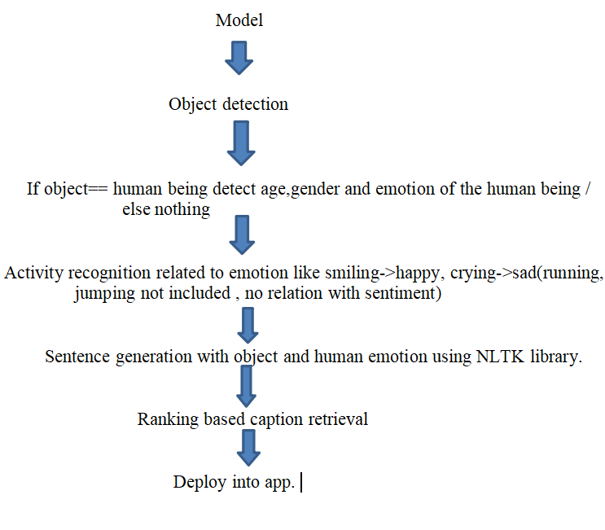

## **2.2 Product Functions**

The function of this product is:

It can generate the caption for the images fed by users based on their sentiments.

The user must give the required camera,storage and GPS permission.

Below given diagram shows the **block diagram of the project.**

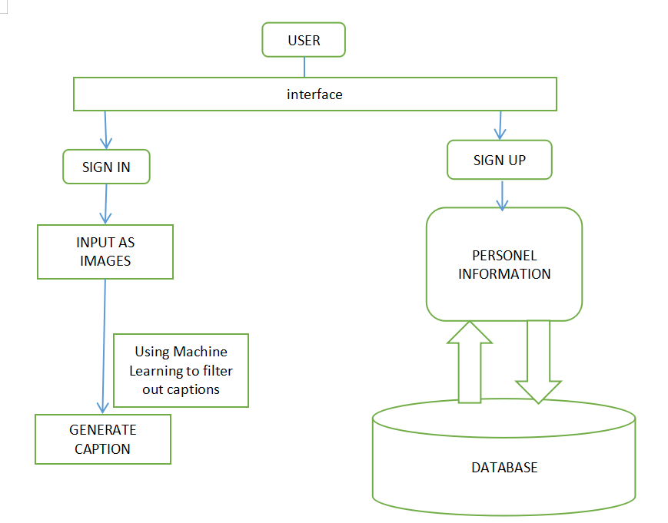

The block diagram of  **Model -Image Caption generator**

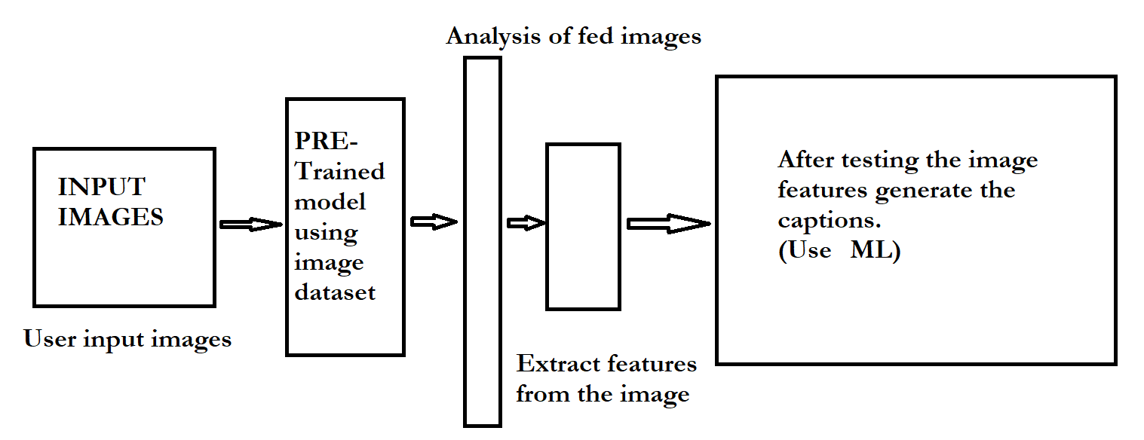

User classification will be there like

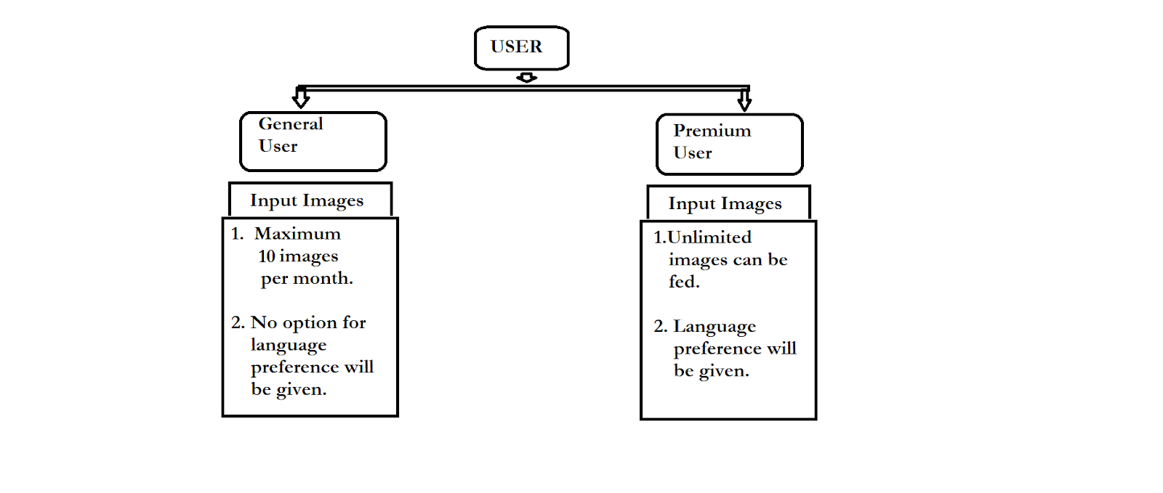

Technology to be used:

/* ML  */

## **2.3 User Classes and Characteristics**

The user demograph is restricted to active social media users. Users classes will be differentiated on the basis of general and premium users.

**General member** :-

10 photo / month - user will be able to generate captions for only 10                     images per month.

Caption language: Only English.

**Premium member** :

No limitations for generating captions / month

Caption language:  All languages are supported (English,Hindi,French                 etc).

The users don’t need to be technical experts to use our app.It will be fully secured and the images that user will fed won’t be shared to other users.

**2.4 Operating Environment**

It will work on Android phones,tablets and PCs.

## **2.5 Design and Implementation Constraints**

Constraints:

Camera permission required to be able to take new pictures.

Device permission required to access the stored / pre-existing images.

Gps permission required to generate location appropriate captions.

Sharp images required for the correct prediction of captions.

Sufficient storage space required for app installation.

## **2.6 User Documentation**

*Not yet documented.*

## **2.7 Assumptions and Dependencies**

The performance is dependent on the dataset used to train the model for analyzing the images and generating the caption.

Accuracy of the model is dependent on the resolution of the images fed.

Dependent on third-party translator to generate image captions in different languages for premium users.

# **3. External Interface Requirements**

## **3.1 User Interfaces**

*<Describe the logical characteristics of each interface between the software product and the users. This may include sample screen images, any GUI standards or product family style guides that are to be followed, screen layout constraints, standard buttons and functions (e.g., help) that will appear on every screen, keyboard shortcuts, error message display standards, and so on. Define the software components for which a user interface is needed. Details of the user interface design should be documented in a separate user interface specification.>*

## **3.2 Hardware Interfaces**

*<Describe the logical and physical characteristics of each interface between the software product and the hardware components of the system. This may include the supported device types, the nature of the data and control interactions between the software and the hardware, and communication protocols to be used.>*

## **3.2 Software Interfaces**

*<Describe the connections between this product and other specific software components (name and version), including databases, operating systems, tools, libraries, and integrated commercial components. Identify the data items or messages coming into the system and going out and describe the purpose of each. Describe the services needed and the nature of communications. Refer to documents that describe detailed application programming interface protocols. Identify data that will be shared across software components. If the data sharing mechanism must be implemented in a specific way (for example, use of a global data area in a multitasking operating system), specify this as an implementation constraint.>*

## **3.4 Communications Interfaces**

*<Describe the requirements associated with any communications functions required by this product, including e-mail, web browser, network server communications protocols, electronic forms, and so on. Define any pertinent message formatting. Identify any communication standards that will be used, such as FTP or HTTP. Specify any communication security or encryption issues, data transfer rates, and synchronization mechanisms.>*

# **4. System Features**

*<This template illustrates organizing the functional requirements for the product by system features, the major services provided by the product. You may prefer to organize this section by use case, mode of operation, user class, object class, functional hierarchy, or combinations of these, whatever makes the most logical sense for your product.>*

**4.1    User login**

**4.1.1    Description/Priority**

i.       On clicking the android application icon a sign-up option will pop up(for

the first time), where the user will have to enter emailId,password, name

and     other     personal details.

And he will  be asked to update a profile picture if he wants otherwise       can update later.

ii.    Priority is High.

Only one account can be created using an email-Id.

**4.1.2    Stimulus/Response Sequence**

    Stimulus: User clicks on App-icon.

        Response: Login Page is displayed.

        Stimulus: User Enters Username and Password.

        Response: Username and Password are validated from NoSQL Database.

        Stimulus: User Clicks on Login Button.

    Response: Home Page is displayed if Username and Password is correct                 else Error Message is displayed.

**4.1.3 Functional Requirements.**

▪ The system shall send an approval request on entering the details by the user.

▪ All the information stored in the database.

▪ A verification mail is sent to the users whenever he/she registers for the first time.

▪ The server shall automatically update the database in case of any change in the information.

**4.2    Image Selection**

**4.2.1    Description and Priority**

i.     User will be able to select photos either from gallery  or scan direct

photos from camera app itself and upload it in the app.

ii.  Priority is Medium.

**4.2.2    Stimulus/Response Sequence**

Stimulus: User clicks on “gallery-icon” or “ camera” on app to select                   images.

        Response: User is directed to the gallery or camera a/c to his/her choice.

        Stimulus: User will choose and click the required image.

        Response: The image will be selected.

**4.1.3 Functional Requirements.**

▪ The system shall be able to access the storage and camera.

▪ The system shall be able to recognise the user according to the profile picture provided using facial recognition(if provided).

▪ The system shall be able to save the feeded image and captions (text formats generated in the app itself.

**4.3    Payment option**

**4.3.1    Description and Priority**

To become premium users,the user will have an option to select a plan     whatever he wants for which he will be directed to a payment gateway     for the further transaction.

**4.3.2    Stimulus/Response Sequences**

        Stimulus : User will click on the option “premium user”.                    Response : The system will ask to choose a plan.                        Stimulus : User selects any plan                                    Response : The system redirects him to payment gateway.

After successful payment, the system “congrats” user on becoming     premium user and his membership is changed to premium in database.

**4.1.3 Functional Requirements.**

The system will be able to capture the credit card transaction and will

encrypt the transaction information.

Then the system shall route it to the credit card processor and shall return

either an approval or decline notice.

The user will be able to know whether or not their credit card was approved.

**4.4    Output(Caption Generation)**

**4.4.1** As the user will feed the image, our system in backend will be using               sentiment analysis described in sec 2.1 to generate the appropriate caption.

**4.4.2**  The system will generate the captions in text format with an option to             copy the generated output(caption) on clipboard.

**4.4.3**

The system will allow the image which was feeded as input to be directly shared on the social apps present in the user phone.

The copied text can be pasted on social media apps as a caption for the image.

**4.5    Feedback Option**

**4.5.1    Description and Priority**

i. The user will have to give ratings according his satisfaction after generating captions.

ii. Priority is Medium.

**4.5.2    Stimulus/Response Sequences**

        Stimulus : User will have to fill the feedback form displayed.                 Response : Form will be opened and have options where user can give                 ratings.                                        Stimulus : User completes all the ratings.                            Response:Window closes.

**4.5.3 Functional Requirements.**

▪ Only admin will be able to access the feedback given by user.

# **1. Other Nonfunctional Requirements**

## **1.1 Performance Requirements**

*<If there are performance requirements for the product under various circumstances, state them here and explain their rationale, to help the developers understand the intent and make suitable design choices. Specify the timing relationships for real time systems. Make such requirements as specific as possible. You may need to state performance requirements for individual functional requirements or features.>*

## **1.2 Safety Requirements**

*<Specify those requirements that are concerned with possible loss, damage, or harm that could result from the use of the product. Define any safeguards or actions that must be taken, as well as actions that must be prevented. Refer to any external policies or regulations that state safety issues that affect the product’s design or use. Define any safety certifications that must be satisfied.>*

## ***1.3 Security Requirements***

*<Specify any requirements regarding security or privacy issues surrounding use of the product or protection of the data used or created by the product. Define any user identity authentication requirements. Refer to any external policies or regulations containing security issues that affect the product. Define any security or privacy certifications that must be satisfied.>*

## **1.4 Software Quality Attributes**

*<Specify any additional quality characteristics for the product that will be important to either the customers or the developers. Some to consider are: adaptability, availability, correctness, flexibility, interoperability, maintainability, portability, reliability, reusability, robustness, testability, and usability. Write these to be specific, quantitative, and verifiable when possible. At the least, clarify the relative preferences for various attributes, such as ease of use over ease of learning.>*

## **1.5 Business Rules**

*<List any operating principles about the product, such as which individuals or roles can perform which functions under specific circumstances. These are not functional requirements in themselves, but they may imply certain functional requirements to enforce the rules.>*

# **2. Other Requirements**

*<Define any other requirements not covered elsewhere in the SRS. This might include database requirements, internationalization requirements, legal requirements, reuse objectives for the project, and so on. Add any new sections that are pertinent to the project.>*

**Appendix A: Glossary**

*<Define all the terms necessary to properly interpret the SRS, including acronyms and abbreviations. You may wish to build a separate glossary that spans multiple projects or the entire organization, and just include terms specific to a single project in each SRS.>*

**Appendix B: Analysis Models**

*<Optionally, include any pertinent analysis models, such as data flow diagrams, class diagrams, state-transition diagrams, or entity-relationship diagrams.>*

**Appendix C: To Be Determined List**

*<Collect a numbered list of the TBD (to be determined) references that remain in the SRS so they can be tracked to closure.>*